

# Daily Progress Report

|  |  |
| --- | --- |
| **Installation / Location** | Halul Island |
| **Subject** | Corrosion Monitoring Activities |
| **Contract Number** | LC241047A0 |
| **Assigned Petromech Representatives** | Shuaib Palakkavalappil |
| **Date of Issue** | 20-08-2025 |

## Activities Summary

Today morning 7:30AM departure and arrived HALUL at 08:00AM, MR:CULBERT took us QAT office, At the office conducted a safety instruction class by HSE.

Today’s activities includes the complete inspection and pressure test of 37”RBS Retrieval tool (2500psi) at 2500 psi pressure for 30 minutes.

Packing of materials which are needed for tomorrow at PS-3 for scheduled work are done and make it ready for shipment

|  |  |
| --- | --- |
| **Time** | **Activities** |
| 08;00 to 09:00 | Mobilization and Safety induction class |
| 09:00 to 11:00 | Inspect and Rebuild of 37” RBS Retrieval tool(2500psi) at 2500psi pressure for 30 minutes |
| 11:00 to 12:30 | Lunch |
| 12:30 to 18:00 | Inspecting and Packing/Loading of relevant materials which need to used at PS-3 for tomorrow on to pallets. Create packing list |

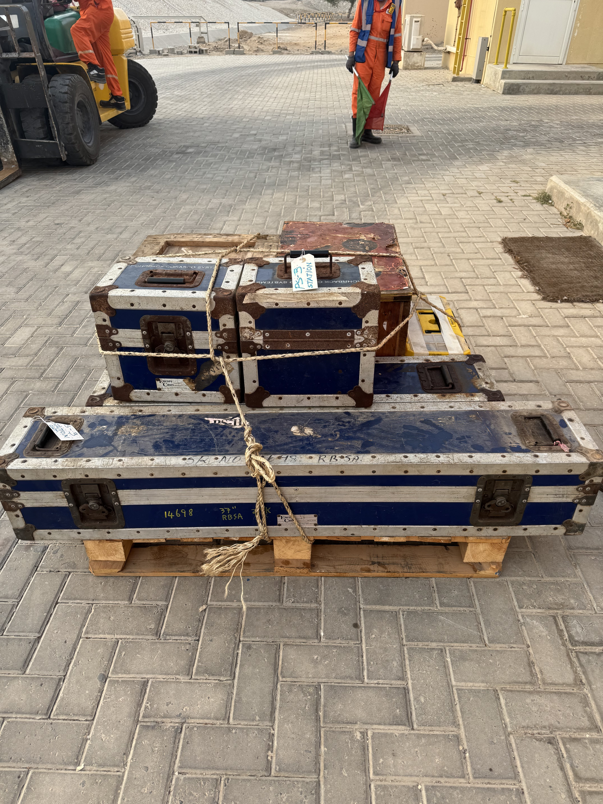

## 37” RBS RETREIVAL TOOL (2500PSI) NO:4696

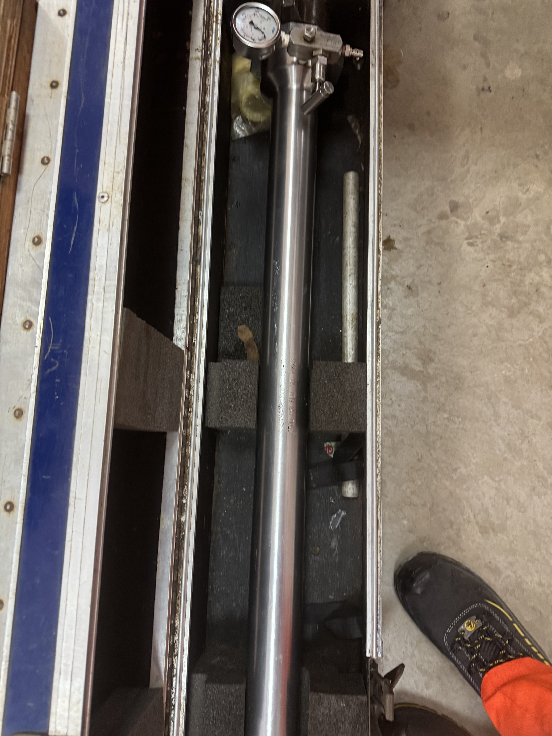

## Observations & Recommendations

The 37” RBS Retrieval tool working properly as per the pressure test.The ENERPAC Hydraulic pressure pump and TANGYE pump is not working properly and need maintenance.

**24 Hour Lookahead**

The materials for PS-3 scheduled work is ready for shipment,The plan for Thursday 21-08-2025 hopefully will done as expected.

**Shuaib Palakkavalappil** – PETROMECH. – shuaib.p@petromech.com.qa